Sample Output:

*Screen shot of users tweet:*

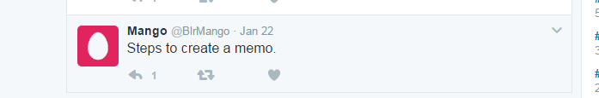

*Reply from the python_twitter_bot for “Steps to create a memo.” tweet posted by a user.*

* *Logged in as: @GManishakrishna:*

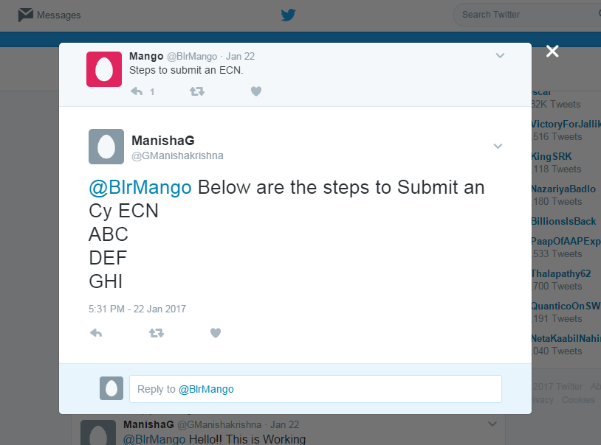

* *Logged in as: @BlrMango:*

